Community Advisory Council
Expression of Interest Form

Overview: Community Advisory Councils
The role of the Community Advisory Councils (CACs) is to provide the Board of the Central Queensland, Wide Bay, Sunshine Coast PHN, with locally relevant perspectives on community health issues.

The Community Advisory Councils (CACs) will deliver local viewpoints to the Board to empower decisions that are cost-effective and connected to real regional health care experiences and expectations. The CACs will include committed, informed members who are able to engage with health and wellness issues towards facilitating effective, sustainable and equitable outcomes for their local community.

The PHN will have three Community Advisory Councils which are aligned with the Hospital and Health Service boundaries:
- Central Queensland;
- Wide Bay; and
- Sunshine Coast.
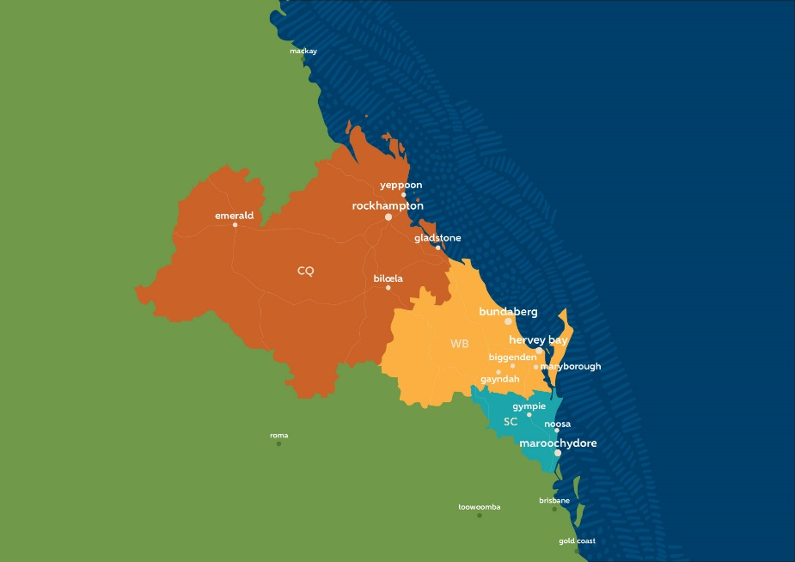
PHNs were established by the Federal Government with the key objectives of increasing the efficiency of health services for all. The PHN goals particularly centres around those at risk of poor health outcomes and improving coordination of information, prevention and care strategies to ensure communities receive the right service, in the right place at the right time.

Expression of Interest
The PHN now invites submissions from individuals who are interested in becoming members of the Community Advisory Councils.
The term ‘Community’ refers to groups of people or organisations with a common local or regional interest in health. Communities may connect through a community of place such as a neighbourhood, region, suburb; a community of interest such as patients, industry sector, profession or environment group; or a community that forms around a specific issue such as improvements to public health care or through groups sharing cultural backgrounds, faith, identity or languages.
The CAC will be comprised of community members with the necessary skills (or ability to acquire skills) to participate in a council environment and who are willing and able to represent the PHN. The basis of the membership includes participants from a cross-section of the community, across geographical area and representing a variety of lived or cultural experience/s.
Expressions of interest for membership of a specific CAC will be viewed more favourably if you are a resident in that community. Applicants must be a resident of the Central Queensland, Wide Bay, Sunshine Coast PHN region. Successful applicants will be eligible for remuneration for their contribution.

For more information please see the Community Advisory Council Terms of Reference (ToR).

To submit your application:
Step 1: | Include this form and your personal information with your application.
Step 2: | Provide information demonstrating your interest and experience (personal or professional) and suggest how this can contribute to the success of the Community Advisory Council. Also note any actual or perceived conflicts of interest in this section. Please do not exceed three pages in total.
Step 3: | Your Expression of Interest should be emailed to HWills@ourphn.org.au

If you have any questions relating to this application, please contact Heather Wills on 4921 7777 or via email.

Step 1: Personal information
First Name: Click here to enter text. Last Name: Click here to enter text.
Phone Number: Click here to enter text.
Email Address: Click here to enter text.

Postal Address
Street Click here to enter text.
Suburb Click here to enter text. Postcode Click here to enter text.
Town or District

Residential Address
Street Click here to enter text.
Suburb Click here to enter text. Postcode Click here to enter text.
Town or District

Key Health Area of interest and expertise (please limit to 3 areas):

Role or Occupation: Click here to enter text.

Employer (if relevant): Click here to enter text.

Community Advisory Council you are expressing interest in:

Central Queensland

- Wide Bay

- Sunshine Coast

Do you identify as Aboriginal and/or Torres Strait Islander?

Yes ________________________

No ________________________

Other _______________________

Step 2: Information demonstrating interest and experience
To be considered for appointment, suitability will be assessed based on the following information (maximum 3 pages in total). Please attach any brief additional information to your application form.

2.1 Describe your community or health background, including experience with the health sector in your local region.

2.2 Outline your motivation for joining the Community Advisory Council. What is it that you hope the Community Advisory Councils can achieve?

2.3 Outline your experience in working as part of a committee or council. List any community or health groups that you are a working member of at present.

2.4 Provide an example of how you encouraged each member of a working group to have an equal voice in order to achieve change.

2.5 Outline any perceived or actual conflicts of interest that may exist if you were successful in this role.

2.6 Please provide the name and contact details of two referees:

- Name
Phone
Email
Nature of reference

- Name
Phone
Email
Nature of reference

